**Hotel Management System**

**ERD Diagram:**

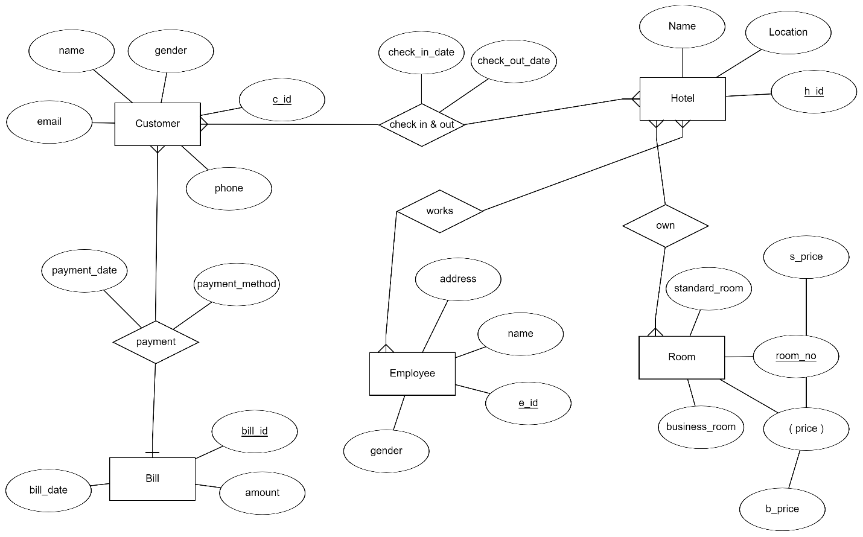

**Relational Schema:**

